PROMPT ENGINEERING
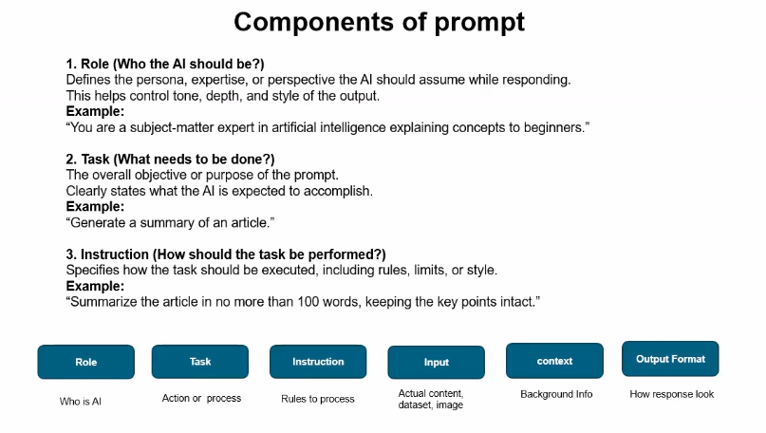
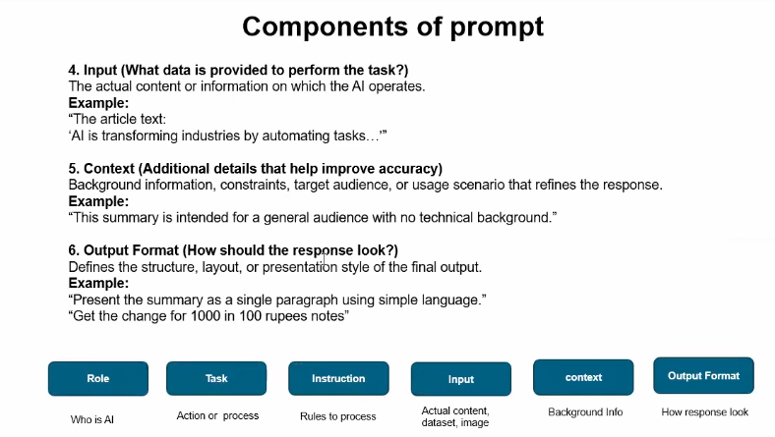

What Are Sampling Parameters in Prompt Engineering?
When you use a Generative AI model (like ChatGPT), the model does not just pick the highest-probability next word every time.
Instead, it samples from a probability distribution over possible next words.
Sampling parameters control how the model chooses the next word.
They control creativity, randomness, and diversity of the output.

Why Sampling Parameters Matter
Same prompt + Different parameters = Different outputs
They help you control:
- Creativity
- Determinism
- Diversity
- Repetition
- Length
Main Sampling Parameters

Temperature (Most Important)
Controls randomness.
- Range: usually 0 → 2
- Default: around 0.7

Low Temperature (0 – 0.3)
- More deterministic
- More factual
- Less creative
- Safer answers
Good for:
- Coding
- Math
- Factual explanations

High Temperature (0.8 – 1.5)
- More creative
- More diverse
- Sometimes less accurate
Good for:
- Story writing
- Brainstorming
- Creative content
Think of temperature as:
How “adventurous” the AI is.

Top-k Sampling
Instead of choosing from all possible words:
- Model considers only the top k most probable words
- Then samples from them
Example:
- If k = 5 → only top 5 candidate words considered
Lower k → safer
Higher k → more diverse

Top-p (Nucleus Sampling)
Instead of fixed number (k):
- Choose smallest set of words whose total probability ≥ p
Example:
- p = 0.9 → choose words covering 90% probability mass
More adaptive than top-k.
Most modern systems prefer top-p over top-k.

Frequency Penalty
Reduces repetition of words that already appeared.
Higher value → Less repetition
Useful for:
- Long answers
- Story writing

Presence Penalty
Encourages the model to talk about new topics.
Higher value → Model explores new concepts.

Max Tokens
Controls maximum output length.
Does not affect creativity — only length.
